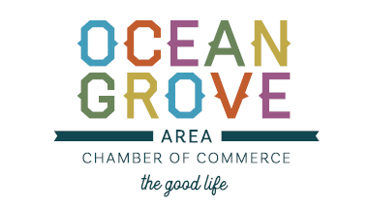

P.O. Box 415 Ocean Grove, NJ

732.774.1391 / [info@oceangrovechamber.org](mailto:info@oceangrovechamber.org)

The OGACC’s Code of Conduct is in place to ensure the wellbeing of all of our event participants. Our expectation is that Vendors treat customers, staff, volunteers, business owners and law enforcement courteously. It is the OGACC’s intent to host events that create a friendly, safe and successful atmosphere for all who are involved.

As a vendor for any OGACC events, I will:

* Respect and adhere to all rules established by the OGACC
* Treat all customers, staff and participants with respect and courtesy. Aggressive or rude behavior towards others is unacceptable and will not be tolerated.
* Not willingly deceive or exploit customers, the event coordinator, staff, business owners or volunteers.
* Follow the guidelines set forth regarding what items are allowed to be sold and what items are not permitted or illegal to be sold.
* Respect the event space by cleaning up any debris, merchandise and garbage prior to vacating the space. Vehicles are not permitted to be parked or driven on the event green, grass, sidewalks or anywhere that cars are not normally permitted.
* Adhere to loading and unloading rules and conduct, as well as the set up and break down time frames.

As a vendor of the OGACC events, I agree to sell items that are:

* (Craft Shows) Completely handmade, by the applying vendor, within a 5% margin.
* Family friendly items. These items and items of this nature are **not permitted**: items that are deemed pornographic, weapons, illegal substances, vulgar language, political, fireworks or any items that are dangerous.

As a vendor of the OGACC it is important that all components of our Code of Conduct are followed. Failure to comply with any component of the OGACC Code of Conduct will result in vendor privileges being revoked for all OGACC shows and markets with no refunds issued.