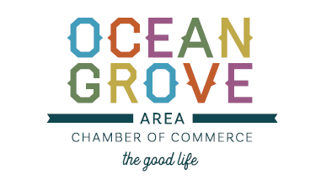

October 1, 2020

Dear Vendors,
We are excited to announce a new Ocean Grove Area Chamber of Commerce event for 2020, The Ocean Grove Holiday Festival on December 5th 2020. This event will be a craft show similar to our Fall Harvest Festival. It will be open to Crafters and Artisans who specialize in Holiday items. Since this is a brand new event for us we will opening up applications to all crafters and artisans that hand make Holiday items. If you think this show is right for you please fill out the application completely. All items MUST be handmade within in a 5% margin. Space is very limited and ALL vendors regardless of past experience must be approved. As part of the application process pictures of work or a website to view items must be included.
We are so excited to add this festival to our roster of events for the 2020 Holiday season.

Please reach out with any question you have 732.774.1391 or email at info@oceangrovechamber.org
Thank you for your participation in our events,
Ocean Grove Area Chamber of Commerce Events Committee
Info@oceangrovechamber.org / 732-774-1391

